Assignment 2.1
TASK 1: write a Python function that reads
a list of numbers and calculates the mean, minimum, and
maximum values
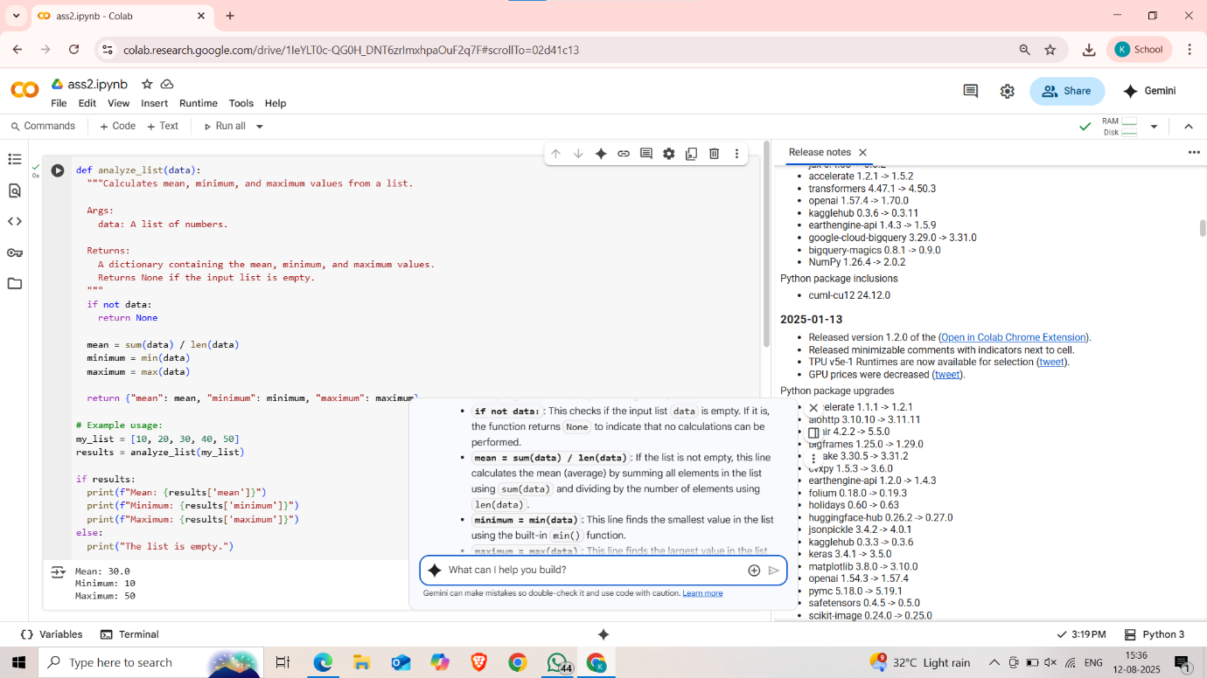
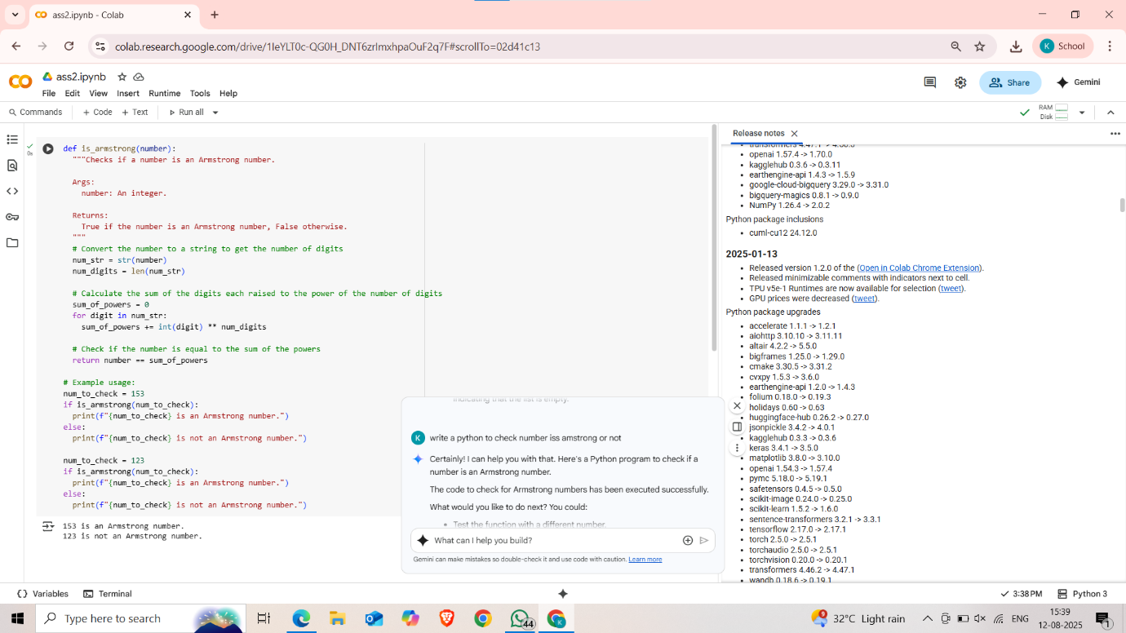
TASK 2:
Python function that
checks whether a number is an Armstrong number.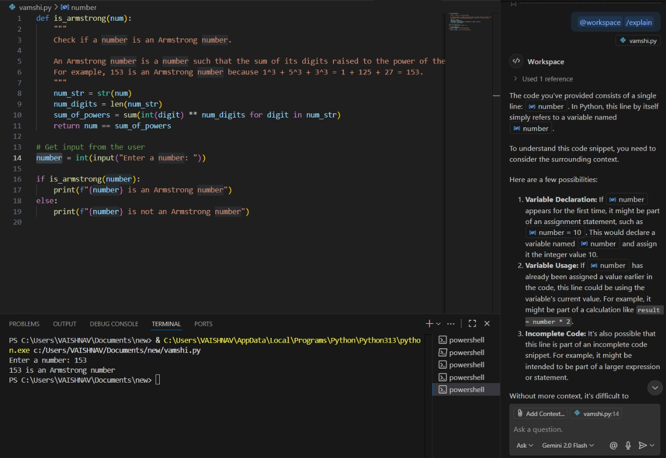

TASK 3: Python function (e.g., is_prime(n) or
is_palindrome(s)) line by line.
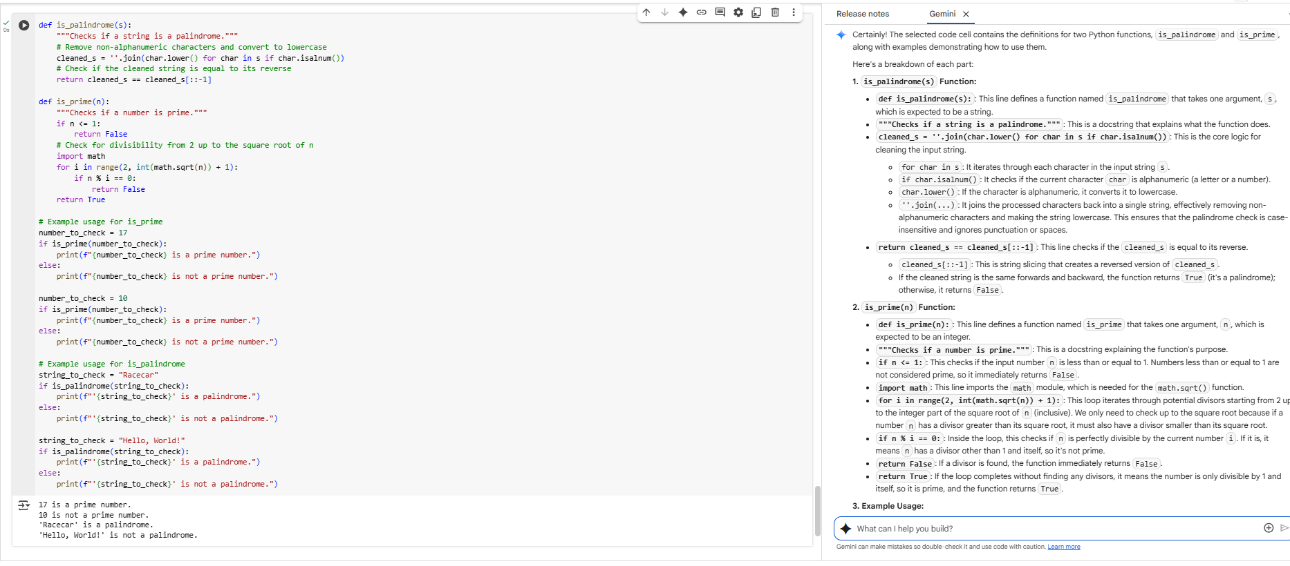
TASK 4: Generate a Python
function (e.g., sum of the first N natural numbers)
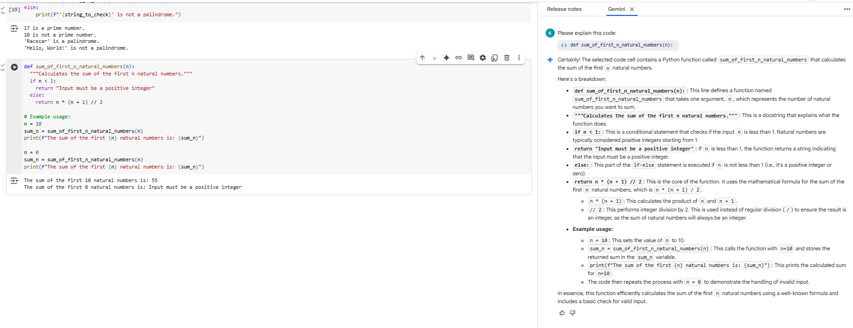

TASK 5: Python program to calculate the sum of
odd numbers and even numbers in a given tuple
